This homework assignment is based on Chapter 10 Classes.

**There are two projects, each worth 50%**

Project #1

**#1 print screen the output and the code from all classes below here.**

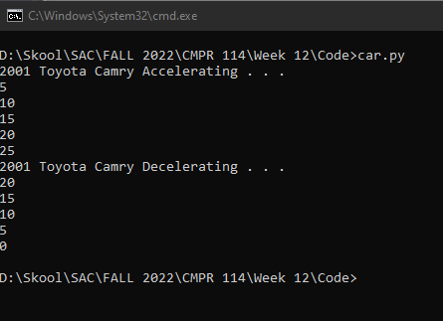

class Car(object):

def __init__(self, year, make):

self.__year = year

self.__make = make

self.__speed = 0

def accelerate(self):

#Accelerate car.

self.__speed += 5

def brake(self):

#Decelerate car.

self.__speed -= 5

def get_speed(self):

#Get current speed of car.

return self.__speed

def main():

# create a Car object

car = Car("2001", "Toyota Camry")

# calls the accelerate method

print ("Accelerating . . .")

for i in range(5):

car.accelerate()

print (car.get_speed())

# calls the brake method five times.

print ("Decelerating . . .")

for i in range(5):

car.brake()

print (car.get_speed())

if __name__ == "__main__":

main()

Project #2

**#2 print screen the output and the code from all classes below here.**

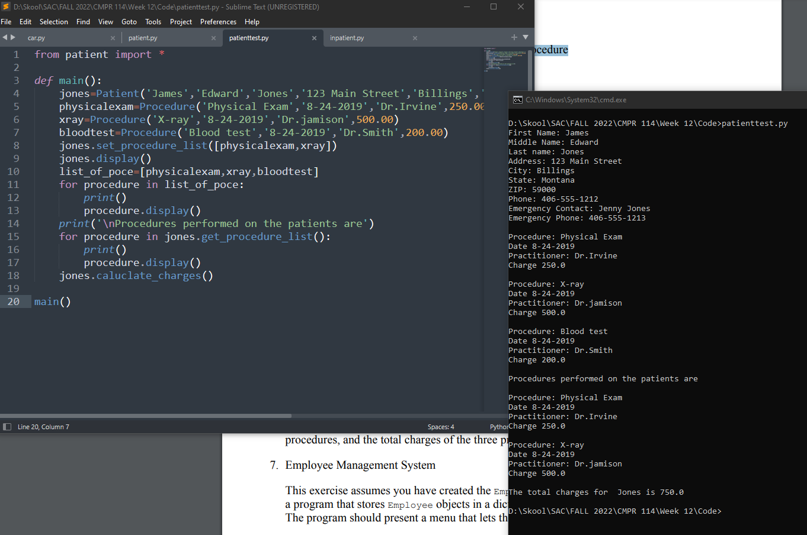from patient import *

def main():

jones=Patient('James','Edward','Jones','123 Main Street','Billings','Montana',59000,'406-555-1212','Jenny Jones','406-555-1213')

physicalexam=Procedure('Physical Exam','8-24-2019','Dr.Irvine',250.00)

xray=Procedure('X-ray','8-24-2019','Dr.jamison',500.00)

bloodtest=Procedure('Blood test','8-24-2019','Dr.Smith',200.00)

jones.set_procedure_list([physicalexam,xray])

jones.display()

list_of_poce=[physicalexam,xray,bloodtest]

for procedure in list_of_poce:

print()

procedure.display()

print('\nProcedures performed on the patients are')

for procedure in jones.get_procedure_list():

print()

procedure.display()

jones.caluclate_charges()

main()

from patient import *

class InPatient(Patient):

def __init__(self,fname,mname,lname,adress,city,state,zipcode,phnum,emname,emphnum,days_in):

super().__init__(fname,mname,lname,adress,city,state,zipcode,phnum,emname,emphnum)

self.days_in=days_in

def set_days(self,days):

self.days_in=days

def show(self):

self.display()

print('Days:',self.days_in)

print("The total charge for",self.last_name, "is $",self.days_in*50)

def main():

smith=InPatient('Will','Thomas','Smith','456 South Street','Dallas','Texas',75050,'214-555-1234','Carol Smith','214-555-4567',3)

smith.show()

main()

import datetime

class Patient:

def __init__(self,fname,mname,lname,adress,city,state,zipcode,phnum,emname,emphnum):

self.first_name=fname

self.middle_name=mname

self.last_name=lname

self.adress=adress

self.city=city

self.state=state

self.zipcode=zipcode

self.phone_number=phnum

self.emergency_name=emname

self.emergency_phone_number=emphnum

self.procedure_list=[]

def get_first_name(self):

return self.first_name

def get_middle_name(self):

return self.middle_name

def get_last_name(self):

return self.last_name

def get_adress(self):

return self.adress

def get_city(self):

return self.city

def get_state(self):

return self.state

def get_zipcode(self):

return self.zipcode

def get_phone_number(self):

return self.phone_number

def get_emergency_name(self):

return self.emargency_name

def get_emergency_phone_number(self):

return self.emergency_phone_number

def get_procedure_list(self):

return self.procedure_list

def set_first_name(self,first_name):

self.first_name=first_name

def set_middle_name(self,middle_name):

self.middle_name=middle_name

def set_last_name(self,last_name):

self.last_name=last_name

def set_adress(self,adress):

self.adress=adress

def set_city(self,city):

self.city

def set_state(self,state):

self.state=state

def set_zipcode(self,zipcode):

self.zipcode=zipcode

def set_phone_number(self,phone_number):

self.phone_number=phone_number

def set_emergency_name(self,emargency_name):

self.emargency_name=emargency_name

def set_emergency_phone_number(self,emergency_phone_number):

self.emergency_phone_number=emergency_phone_number

def set_procedure_list(self,procedure_list):

self.procedure_list=procedure_list

def caluclate_charges(self):

total_charges=0

for procedure in self.procedure_list:

total_charges=total_charges+procedure.get_charges()

print('\nThe total charges for ',self.last_name,'is',total_charges)

def display(self):

print('First Name:',self.first_name)

print('Middle Name:',self.middle_name)

print('Last name:',self.last_name)

print('Address:',self.adress)

print('City:',self.city)

print('State:',self.state)

print('ZIP:',self.zipcode)

print('Phone:',self.phone_number)

print('Emergency Contact:',self.emergency_name)

print('Emergency Phone:',self.emergency_phone_number)

class Procedure:

def __init__(self,procedure_name,date,practitioner_name,charges):

self.procedure_name=procedure_name

self.date=date

self.practitioner_name=practitioner_name

self.charges=charges

def get_procedure_name(self):

return self.procedure_name

def get_date(self):

return self.date

def get_practitioner_name(self):

return self.practitioner_name

def get_charges(self):

return self.charges

def set_procedure_name(self,procedure_name):

self.procedure_name=procedure_name

def set_date(self,date):

self.date=date

def set_practitioner_name(self,practitioner_name):

self.practitioner_name=practitioner_name

def set_charges(self,charges):

self.charges=charges

def display(self):

print('Procedure:',self.procedure_name)

print('Date',self.date)

print('Practitioner:',self.practitioner_name)

print('Charge',self.charges)

**Submit this document to Module 12 Homework.**